

**SMART PARKING SYSTEM**

**A MINI PROJECT REPORT**

***Submitted by***

**KAMALI S (1920110019)**

**NIKITHA LAKSHMI J (192011031)**

**PRIYAADHARSHINI V S (1920110036)**

***in partial fulfilment for the award of the degree***

***of***

**BACHELOR OF TECHNOLOGY**

**IN**

ARTIFICIAL INTELLIGENCE AND DATA SCIENCE

**SONA COLLEGE OF TECHNOLOGY, SALEM-5**

**(Autonomous)**

**ANNA UNIVERSITY: CHENNAI 600 025**

NOVEMBER 2023

**ANNA UNIVERSITY: CHENNAI 600 025**

**BONAFIDE CERTIFICATE**

Certified that this project report “**SMART PARKING SYSTEM”** is the bonafide work of **“KAMALI S (1920110019), NIKITHA LAKSHMI J (192011031), PRIYAADHARSHINI V S (1920110036)”** who carried out the project work under my supervision.

**SIGNATURE**

**SIGNATURE**

Dr. J. Akilandeswari

Dr.P. Iyyanar

**HEAD OF THE DEPARTMENT**

**SUPERVISOR**

Professor

Associate Professor

Department Of Information Technology

Department Of Information Technology

Sona College of Technology

Sona College of Technology

Salem- 636 005.

Salem- 636 005.

Submitted for Project viva voce examination held on

|  |  |
| --- | --- |
| **INTERNAL EXAMINER** | **EXTERNAL EXAMINER** |

i

**ACKNOWLEDGEMENT**

First and foremost, we thank to **power of almighty** for showing us inner peace and for all blessings. Special gratitude to our parents, for showing their support and love always.

We express our sincere thanks to chairman **Sri.C. VALLIAPPA** and principal **Dr.S.R.R.SENTHILKUMAR** for providing adequate facilities to complete the project.

We are immensely grateful to our Head of Information Technology Department, **Dr.J. AKILANDESWARI for** the continue encouragement to complete theproject.

We express our heartfelt thanks to our project supervisor **Dr.P. IYYANAR** for his valuable guidance and fruitful discussions throughoutthe course of the project work.

We feel proud in sharing this success with all our department Faculty, Staff members and friends who helped directly and indirectly to completing this project successfully.

ii

**ABSTRACT**

The proposed smart parking system revolutionizes traditional parking methods by leveraging IoT technology and a minimalistic setup of two IR sensors, one at the entrance and one at the exit. These IR sensors efficiently detect the presence of vehicles as they enter and leave the parking area. When a car enters, the entrance sensor triggers the system to update the central database, indicating that a spot is occupied. Similarly, when a vehicle exits, the exit sensor signals the system to mark the spot as available again. The central database continually updates the status of parking slots based on this real-time information.

To benefit users, an LCD display strategically positioned at the parking lot entrance showcases the current availability of parking spots. This display communicates the number of vacant slots, guiding drivers to easily identify open spaces without the hassle of searching. This straightforward approach reduces congestion and frustration associated with finding parking, enhancing the overall parking experience.

By employing only two IR sensors and an intuitive LCD display, this smart parking system optimizes resources, minimizes infrastructure requirements, and offers a user-friendly solution. Its simplicity combined with IoT technology delivers real-time parking information, transforming the parking landscape and making urban parking more efficient and convenient for all.

iii

**TABLES OF CONTENT**

|  |  |  |
| --- | --- | --- |
| **CHAPTER NO.** | **TITLE** | **PAGE NO.** |
|  | **ABSTRACT** | **iii** |
|  | **LIST OF FIGURES** | **v** |
|  | **LIST OF ABBREVIATION** | **vi** |
| **1** | **INTRODUCTION**   * 1. Objectives   2. Characteristics   3. Scopes   4. Hardware Components   1.4.1 Sensors  1.4.2 Servomotor  1.4.3 LCD display  1.4.4 Arduino UNO  1.5 Literature Survey  1.5.1 Existing System | **1**  **2**  **2**  **3**  **4**  **4**  **5**  **6**  **7**  **9**  **10** |
| **2** | **SYSTEM ARCHITECTURE**  2.1 Architecture  2.2 Flow Chart  2.3 Implementation of Proposed System   * 1. Modules of The Project   2.4.1 IR Sensor Module  2.4.2 Central Control System  2.4.3 LCD Display Module  2.4.4 IoT Connectivity Module  2.5 Result Analysis | **11**  **11**  **12**  **14**  **16**  **17**  **17**  **17**  **18**  **18** |
| **3** | **CONCLUSION**  3.1 Future Enhancement | **21**  **22** |
|  | **REFERENCES** | **24** |

iv

**LIST OF FIGURES**

|  |  |  |
| --- | --- | --- |
| **FIG.NO** | **TITLE** | **PAGE NO** |
| 1 | INFRARED SENSOR | 4 |
| 2 | SERVOMOTOR | 6 |
| 3 | LED DISPLAY | 7 |
| 4 | ARDUINO UNO | 8 |
| 5 | SYSTEM ARCHITECTURE OF SMART PARKING SYSTEM | 11 |
| 6 | FLOWCHART OF AUTOMATED CAR PARKING | 13 |
| 7 | CIRCUIT DIAGRAM | 15 |
| 8 | MODULES OF THIS PROJECT | 17 |
| 9 | RESULT ANALYSIS | 20 |

v

**LIST OF ABBREVIATIONS**

|  |  |
| --- | --- |
| **ABBREVIATIONS** | **FULL FORMS** |
| IoT | Internet of Things |
| LCD | Liquid Crystal Display |
| IR sensor | Infrared Sensor |
| RFID tags | Radio-Frequency Identification tags |

vi

**CHAPTER 1**

**INTRODUCTION**

Introducing a smart parking system revolutionizing urban parking with simplicity and efficiency. This innovative system relies on just two IR sensors installed at the entrance and exit points of parking facilities. These IR sensors serve as the guardians of parking availability, detecting incoming and outgoing vehicles. As a vehicle approaches the entrance, the first IR sensor activates, swiftly detecting its presence. Simultaneously, the second sensor, stationed at the exit, monitors outgoing traffic. This dynamic duo captures the ebb and flow of vehicles, relaying this critical data to a centralized system.

Within this system, sophisticated algorithms process the information in real-time. The status of parking spaces is continually updated based on the data received from these two sensors. Instantly, this information is relayed to LCD displays strategically positioned across the parking area.These displays act as beacons of guidance for drivers in search of parking spots. The simple yet comprehensive display showcases the available slots, guiding drivers to vacant spaces with ease. This immediate accessibility eliminates the need for aimless circling, reducing congestion and frustration.

Furthermore, this system goes beyond mere convenience. It optimizes parking space utilization, contributing to a more eco-friendly and sustainable urban landscape. By efficiently managing available parking and minimizing unnecessary vehicle movement, it aids in reducing emissions and overall environmental impact. This streamlined approach isn't just about parking; it's about transforming the entire urban experience. It simplifies the search for parking, reduces stress for drivers, and aligns with the growing demands for smarter, more sustainable city infrastructure. In essence, this minimalist yet powerful implementation of IoT-connected IR sensors fundamentally changes the parking landscape. It's a testament to the potential of technology to solve everyday challenges, making urban life more convenient, efficient, and environmentally conscious.

* 1. **OBJECTIVES**

The objective of the smart parking system employing only two IR sensors at the entrance and exit is to streamline parking management and enhance user convenience. By strategically placing sensors at entry and exit points, the system aims to accurately detect vehicle presence, minimizing the need for extensive sensor installations throughout the parking lot. These sensors relay real-time data to a central control unit, which then processes this information to determine available parking slots. The display of this data on LCD screens located prominently within the parking facility allows drivers to swiftly identify open spaces upon entry. This objective seeks to optimize space utilization, reduce search time, and alleviate congestion by providing drivers with accessible and up-to-date information regarding available parking spots. By leveraging minimal sensor deployment and effective data presentation, the system aims to offer a hassle-free and efficient parking experience for users.

* 1. **CHARATERISTICS**

A smart parking system utilizing IoT to detect and display the availability of parking slots via an LCD display offers several notable characteristics that revolutionize parking management and enhance user convenience. Firstly, real-time monitoring and accuracy are paramount. The system employs IoT sensors that detect the presence of vehicles in parking spaces. These sensors continually relay data to a central server, ensuring that the information displayed on the LCD screen is always up to date.

This real-time accuracy saves drivers valuable time that would otherwise be spent searching for available slots. Moreover, the system promotes sustainability and efficiency. By guiding drivers directly to open parking spaces, it significantly reduces fuel consumption and emissions associated with the often-frustrating search for parking. Additionally, the centralized management of parking data enables authorities to optimize the usage of parking facilities efficiently and plan for future expansions based on actual demand.

Furthermore, user-friendliness is a key characteristic. The LCD display is strategically located at key entry points, providing drivers with clear and immediate information on available parking slots. This not only simplifies the parking process but also enhances the overall experience for users. The system is also easily scalable and adaptable, making it suitable for diverse parking environments, from shopping centres and airports to urban streets. Its modularity allows for the addition of more sensors and displays as needed. Furthermore, it's a valuable tool for data collection and analysis, providing insights into usage patterns and helping urban planners make informed decisions about parking infrastructure. In summary, a smart parking system using IoT to detect and display available parking slots on an LCD display brings real-time accuracy, sustainability, efficiency, user-friendliness, scalability, and valuable data insights to parking management, greatly benefiting both drivers and city authorities.

* 1. **SCOPE**

The scope for a smart parking system utilizing IoT with only two IR sensors at the entrance and exit points is noteworthy for its simplicity and efficiency. With just two sensors, the system can detect the presence of vehicles entering and leaving the parking facility. The real-time data from these sensors is then processed to determine the availability of parking slots. This streamlined approach significantly reduces the complexity and cost of sensor deployment while still providing valuable information to users.

The use of an LCD display at the entrance further enhances user experience by instantly showcasing the available parking slots, guiding drivers efficiently. This simplified setup makes the system easily scalable for smaller parking areas, such as private lots or limited-space environments. Additionally, the integration of IoT ensures that this minimalistic approach remains effective by allowing for remote monitoring and updates. The scope lies in creating a straightforward, user-friendly solution that optimizes parking space utilization and minimizes the time and effort spent in searching for available spots, making it a viable and cost-effective option for various parking scenarios.

* 1. **HARDWARE COMPONENTS**

In this simplified smart parking system, two IR sensors are strategically placed at the entrance and exit. When a vehicle enters or exits, these sensors detect its presence, sending signals to the central control unit. This unit processes the data, determining available parking spots. The information is then showcased on LCD displays placed in visible areas. Drivers access this data, either from displays or a mobile app, guiding them to open parking spaces. These sensors act as gatekeepers, enabling real-time updates on spot availability, streamlining parking, and enhancing user convenience in finding an open spot easily.

**1.4.1 INFRARED SENSORS**

In a simplified smart parking system using IoT, two Infrared sensors are strategically placed at the entrance and exit of the parking facility. These IR sensors act as the eyes of the system, detecting the presence or absence of vehicles as they enter or exit the premises. When a car approaches the entrance, the first IR sensor identifies its presence, signalling the central control unit. Similarly, as a vehicle leaves, the second IR sensor relays information to the system. The central unit processes this data and updates the parking slot availability status in real-time. Users can easily check the information on an LCD display located at a visible spot, ensuring a hassle-free parking experience. This minimalist approach using only two IR sensors at the entrance and exit optimizes the system's efficiency, guiding drivers to available spots with simplicity and effectiveness.

**Fig 1** INFRARED SENSOR

IR sensors are highly reliable and effective in various weather conditions and lighting environments, making them a crucial component in ensuring the efficiency and accuracy of the Smart Parking System as shown in Fig1. In a smart parking system using IoT, IR sensors play a crucial role in revolutionizing the way parking spaces are managed and enhancing overall user experience. IR sensors are integrated into parking spots to detect the presence or absence of vehicles. These sensors emit infrared radiation and measure the reflections, allowing them to accurately determine occupancy in real-time.

The data collected by IR sensors is transmitted through the IoT network to a central control system providing users with up-to-the-minute information about available parking spaces. This real-time data minimizes the frustration and time wasted in searching for parking, contributing to reduced traffic congestion and emissions. Additionally, it enables efficient space management, as operators can analyse occupancy patterns and make data-driven decisions to optimize parking facilities. In a smart parking system, IR sensors leveraged by IoT technology are instrumental in creating a seamless, convenient, and environmentally friendly parking experience.

**1.4.2 SERVOMOTOR**

In a smart parking system using IoT, the integration of servomotors plays a pivotal role in optimizing parking space utilization and enhancing user experience as shown in Fig 2. Servomotors are compact, efficient, and precise electromechanical devices that control the movement of barriers, gates, or platforms within the parking facility. Through the IoT infrastructure, these servomotors can be remotely monitored and controlled, allowing for real-time adjustments in response to changing conditions such as occupancy status and user preferences. In a smart parking system utilizing IoT, servomotors play a crucial role in managing entry and exit points efficiently. When a vehicle is detected by IR sensors at the entrance, the servomotor controls the barrier, allowing access and registering the car's entry. Simultaneously, the system updates the available parking slots based on the occupancy data from the entrance sensor. As the vehicle exits, the exit IR sensor signals the servomotor to open the barrier, updating slot availability.

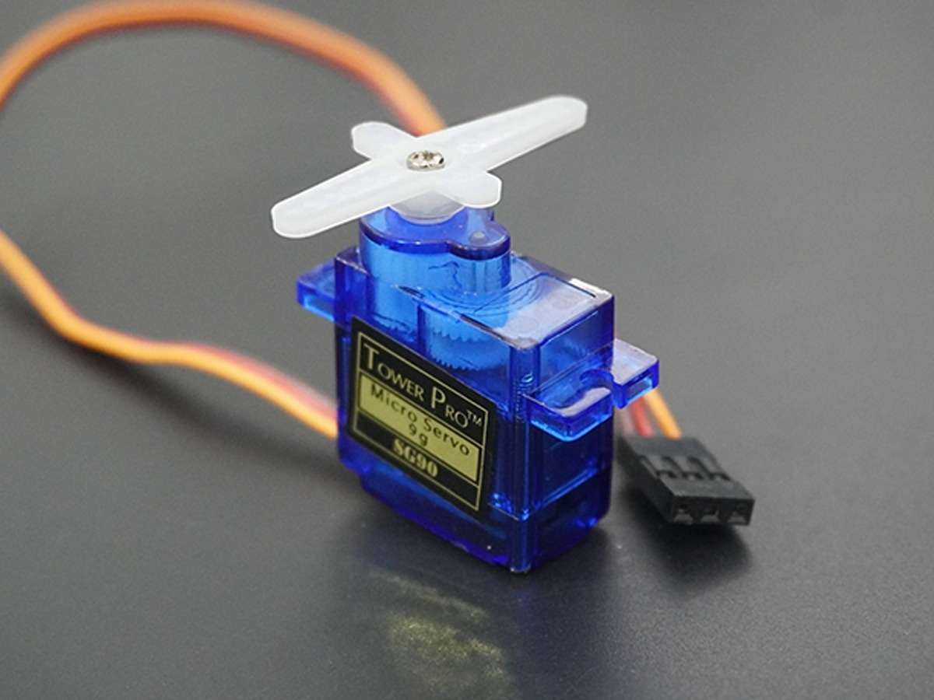

**Fig 2** SERVOMOTORS

This synchronized action of servomotors, triggered by IR sensors, ensures accurate slot information displayed on the LCD, guiding users to available parking spots seamlessly. By leveraging data from sensors and cameras, servomotors can automate tasks like opening and closing barriers at entry and exit points, guiding vehicles to available spots, and even shifting entire parking platforms to maximize capacity. This not only minimizes congestion and reduces the time spent searching for parking but also contributes to the overall efficiency and sustainability of the parking facility. In a smart parking system, servomotors, driven by IoT technology, help streamline the parking process, offering a seamless and convenient experience for users while optimizing space utilization.

**1.4.3 LCD DISPLAY**

The LCD display in the smart parking system acts as a user-friendly interface to show available parking slots. With only two IR sensors one at the entrance and one at the exit the system tracks incoming and outgoing vehicles. As cars enter, the entrance sensor detects occupancy and transmits the data to the central system. Similarly, when a vehicle leaves, the exit sensor updates the system about the empty spot. The LCD display, strategically located, showcases the real-time status of available parking spaces based on this incoming and outgoing data.

For instance, if five spots were empty initially and three cars enter, the display would show only two vacant spots. As cars leave, the display updates accordingly, indicating more available parking spaces. Drivers approaching the parking lot can view this information on the LCD display, making it easier for them to identify open spots quickly without driving around aimlessly as shown in Fig 3. Additionally, this information can be accessed remotely through a mobile app, allowing users to check parking availability even before arriving at the location. By using minimal sensors and a central display, this smart parking system simplifies the parking process, reduces congestion, and improves the overall user experience by providing real-time and accessible information about available parking slots.

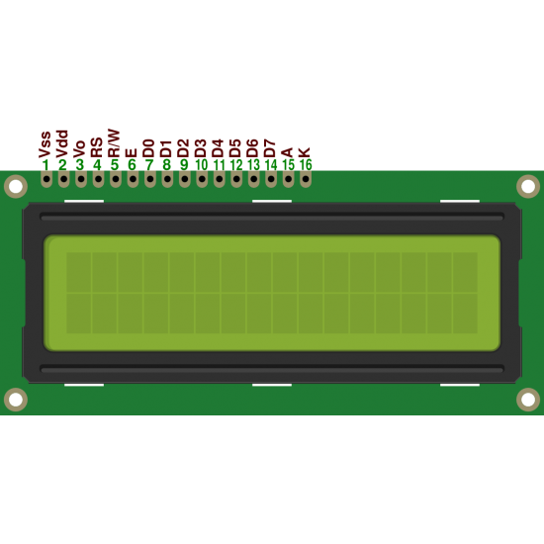

**Fig 3** LCD DISPLAY

**1.4.4 ARDUINO UNO**

The Arduino UNO is the brain behind the smart parking system, serving as the central controller that orchestrates the entire process. With just two IR sensors one at the entrance and another at the exit the Arduino UNO manages the detection of vehicles entering or leaving the parking facility. When a car approaches the entrance, the IR sensor detects its presence and communicates this information to the Arduino UNO. Once the Arduino UNO registers the entry, it dynamically updates the available parking slot count based on the information received. Similarly, when a vehicle exits through the IR sensor at the exit point, the Arduino UNO adjusts the available slot count accordingly. It processes this data swiftly and efficiently.

The Arduino UNO then interacts with an LCD display, showcasing real-time updates on available parking slots as shown in Fig 4. As vehicles come and go, the displayed count changes, providing drivers with immediate information about open spots. This user-friendly interface allows drivers to make informed decisions about where to park without needing to search extensively. The Arduino UNO's role is pivotal, it acts as the nerve centre, coordinating the sensors' input, processing the data, and ensuring that the LCD display accurately reflects the current parking availability. Its capability to manage this information in real-time makes it a crucial component in creating a convenient and efficient smart parking system.

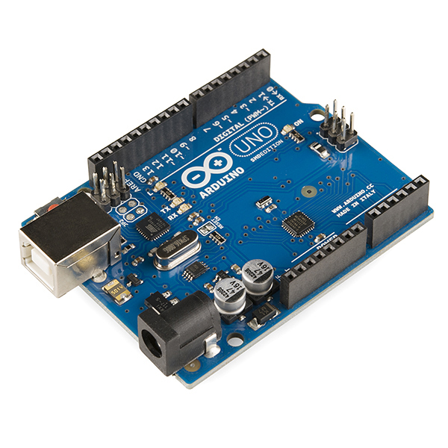.

**Fig 4** ARDUINO UNO

The Arduino Uno, a small but powerful microcontroller, serves as the brain of the smart parking system. It connects and coordinates two IR sensors installed at the entrance and exit. When a vehicle enters or leaves, these sensors detect the car's presence and signal the Arduino Uno. The Uno processes this data and updates the available parking slots accordingly. It then controls an LCD display, showcasing real-time parking availability for drivers. This simplified setup offers a user-friendly solution, guiding users to open spots and minimizing congestion in the parking area.

* 1. **LITERATURE SURVEY**

A literature survey on smart parking systems utilizing IoT technology with IR sensors for car detection and LCD displays for real-time slot availability information reveals a growing body of research and practical implementations aimed at enhancing urban parking infrastructure. IoT-based smart parking systems have gained prominence due to their potential to alleviate traffic congestion, reduce environmental pollution, and improve user convenience.

IR sensors, which efficiently detect the presence or absence of vehicles, play a fundamental role in these systems. They are often embedded in parking spaces and communicate their status to a central control system through wireless IoT connectivity. The integration of IR sensors with LCD displays is a powerful approach that directly benefits both parking operators and users. These displays, strategically placed at entry points or throughout the parking facility, provide real-time information about the availability of parking slots.

Users can easily identify open spaces and navigate directly to them, reducing the time spent searching for parking and consequently lowering vehicle emissions and fuel consumption. Several research studies have explored different aspects of smart parking systems, including the optimization of sensor placement, communication protocols, and data analytics to improve the accuracy of slot availability information. Moreover, the integration of mobile applications and online platforms has been investigated to provide users with the added convenience of reserving parking slots in advance. In conclusion, the literature on smart parking systems utilizing IoT technology with IR sensors and LCD displays showcases a promising field of research and practical applications. These systems have the potential to transform urban parking management, offering real-time information to users and creating more sustainable and efficient parking facilities. Researchers and developers continue to innovate in this space, addressing challenges and advancing the technology for a smarter, greener, and more user-friendly parking experience.

* + 1. **EXISTING SYSTEM**

In the existing smart parking system using IoT with only two IR sensors one at the entrance and another at the exit the functionality is limited compared to more comprehensive systems. These sensors serve as the primary detectors, signalling whether a vehicle enters or exits the parking facility. However, due to the minimal sensor deployment, the system lacks precise information about individual parking spot availability. The data collected by this entrance and exit sensors primarily determine the general occupancy status of the entire parking area rather than specific slot availability.

When a vehicle enters, the entrance sensor detects its presence, and the system registers that a car has occupied at least one spot. Similarly, when a car exits, the exit sensor updates the system, indicating that a parking spot has become available. This basic information is then relayed to an LCD display at the entrance or another visible area, showing a general count of available spots without specifying their exact locations. As a result, drivers arriving at the parking facility have limited guidance regarding where specifically the open spots are located.

Consequently, this system has several drawbacks. Users may still face challenges finding an available parking space as the information displayed is limited to the overall count without indicating their specific positions. This can lead to inefficiencies, increased time spent searching for parking, and potential congestion within the facility. The system's reliance on just two IR sensors limits its ability to provide detailed, real-time data crucial for optimizing space utilization and offering a more user-friendly parking experience.

While the existing system offers a basic understanding of general occupancy, it falls short in providing precise and granular information about available parking spots. Upgrading to a more comprehensive sensor network, distributed across individual parking spaces, would significantly enhance the accuracy and usability of the system, ensuring a smoother parking experience for users.

**CHAPTER 2**

**SYSTEM ARCHITECTURE**

**2.1. ARCHITECTURE DESIGN**

In a smart parking system with two IR sensors at the entrance and exit, the architecture design focuses on efficient car detection and real-time slot availability display. The two IR sensors serve as gatekeepers, detecting incoming and outgoing vehicles. When a vehicle approaches the entrance, the first IR sensor triggers the system to register an available spot. As the vehicle enters, it passes the second IR sensor, indicating occupancy of that spot. Simultaneously, this information is relayed to the central system. The central system manages the parking data and communicates with the LCD displays located strategically in the parking facility. These displays showcase the number of available slots based on the information received from the IR sensors. When a car exits, the second IR sensor detects the departure, updating the central system about the vacant space.

**Fig 5** SYSTEM ARCHITECTURE

In this simplified smart parking system architecture, two IR sensors are placed at the entrance and exit. These sensors detect incoming and outgoing vehicles. When a car enters, the entrance sensor signals the central system, marking the spot as occupied. Similarly, when a vehicle leaves, the exit sensor updates the availability status. The central system processes this data and displays the available slots on LCD screens. Users access this information, guiding them to open spaces. While basic, this design streamlines parking by providing real-time updates using minimal sensors, enhancing the overall parking experience. This architecture as shown in Fig 5 ensures a streamlined process: as cars enter and exit, the system continuously updates the availability status on the displays. Drivers can easily locate open spots by checking these displays or through a mobile app connected to the central system. With just two IR sensors, this simplified design offers a user-friendly way to monitor parking occupancy and guide drivers efficiently to available spaces, reducing congestion and enhancing the overall parking experience.

**2.2. FLOWCHART**

In a simplified flow chart for a smart parking system using IoT with only two IR sensors at the entrance and exit, the process begins as a vehicle approaches. The first IR sensor at the entrance detects the incoming car. If the parking lot is full, the system displays a "Full" message on the LCD display, informing the driver to seek an alternative space. However, if there are available spots, the second IR sensor at the exit confirms the entry, and the system updates the available slots count accordingly.As the car enters and the second IR sensor acknowledges the arrival, the system deducts one from the available slots count and updates the information on the LCD display in real-time. Simultaneously, a timer is activated to monitor the duration of the car's stay. When the car exits, the first IR sensor at the entrance recognizes the departure, incrementing the available slots count. The system then calculates the parking duration using the timer and may display it on the LCD. In a simplified flowchart as shown in Fig 6 for the smart parking system with two IR sensors one at the entrance and another at the exit, the process starts when a car approaches the entrance sensor. The entrance sensor detects the vehicle and sends a signal to the central control system, indicating the occupied space.

**START**

**CONNECT WITH ARDUINO**

**ACTIVE INFRARED SENSORS**

**DISPLAY**

**“NO OF FREE SLOT “**

**IF THERE ANY FREE SLOT**

**DISPLAY “NO FREE SLOT & GATE LOCKED”**

**END**

**Fig 6** FLOWCHART OF AUTOMATED CAR PARKING LOT

Simultaneously, the exit sensor monitors when a car leaves, updating the system to mark the space as available. The control system processes this data and updates the LCD display, showing real-time parking slot availability. Users access this information easily, allowing them to navigate to open spots, enhancing parking efficiency and reducing search time. Throughout this process, the IoT connectivity ensures continuous communication between the sensors and the central system, maintaining the accuracy of the available slots information. This simplified flow chart optimizes the parking experience by providing real-time updates to drivers and promoting efficient space utilization with minimal hardware. It minimizes the need for complex infrastructure, making it a cost-effective and user-friendly solution for smart parking management.

**2.3. IMPLEMENTATION OF PROPOSED SYSTEM**

In the proposed Implementation of a smart parking system utilizing IoT with only two IR sensors one at the entrance and one at the exit. The system undergoes a streamlined process to provide real-time parking information. When a vehicle approaches the entrance, the IR sensor detects its presence and sends a signal to the central control unit, registering that a car has entered the facility. Simultaneously, the system initiates a count of available parking slots based on the current occupancy status.As the vehicle moves through the parking area and eventually exits, the IR sensor positioned at the exit acknowledges the departure, signaling the control unit to update the available parking count accordingly. The control unit constantly processes this data, promptly adjusting the available slots count based on incoming and outgoing vehicles.The LCD display, strategically placed at a visible location within the facility, continuously reflects the real-time parking availability information obtained from the central control unit. For instance, if five slots are available when a vehicle enters, the display will indicate this count. As cars enter or leave, the count updates accordingly, ensuring that drivers approaching the facility can instantly view the number of available parking spaces.

This simplified system with two IR sensors effectively manages parking by monitoring vehicles' entry and exit. Although it provides basic availability information, it significantly enhances the parking experience by minimizing the time spent searching for open spots. Users can quickly assess whether there's space available before entering the parking area, reducing congestion and improving overall efficiency. Despite its simplicity, this implementation optimizes space utilization and offers a more convenient parking solution by leveraging IoT technology and minimal sensor deployment. In the smart parking system with two IR sensors at the entrance and exit, the flowchart starts with the sensors detecting incoming and outgoing vehicles. When a car enters, the entrance sensor sends a signal to the central system, marking the spot as occupied. Simultaneously, the exit sensor updates the system when a car leaves, freeing up the spot. The central system processes this data and calculates available slots. The LCD display receives this updated information, showing the number of open spots to drivers.

**Fig 7** CIRCUIT DIAGRAM

Users access this real-time data to locate and choose available parking spaces efficiently, streamlining the parking experience. To ensure the system's reliability and accuracy, the IR sensors and the LCD display should be calibrated properly as shown in fig 7. Additionally, the system should be equipped with a mechanism for handling exceptions and error messages, such as sensor malfunctions or network connectivity issues. By implementing the proposed system using IoT technology, the efficiency and reliability of parking lot management can be significantly improved. This approach offers a cost-effective solution for managing parking spaces, as it only requires two IR sensors and an LCD display. Moreover, the system's flexibility allows it to be easily adapted to various parking lot configurations and requirements. In conclusion, the implementation of the proposed system using IoT can enhance parking lot management by efficiently detecting and displaying available parking slots. This system's simplicity and low cost make it an attractive option for businesses and organizations seeking to optimize their parking lot operations.

**2.5 MODULES OF THE PROJECT**

The smart parking system using IoT and IR sensors comprises several key modules as shown in Fig 8. In this simplified smart parking system using IoT, two crucial modules, each equipped with IR sensors, orchestrate an efficient and user-friendly experience. At the entrance, the first IR sensor detects the entry of a vehicle, signalling the system to initiate the parking tracking process. Simultaneously, the second IR sensor at the exit tracks the departure of vehicles. These sensors work in tandem to accurately identify the availability status of parking spaces. The data collected from these sensors is then transmitted to a central control unit, where it undergoes processing to determine real-time occupancy information.

Once the central control unit receives and processes the data from the IR sensors, it updates a master database that contains the status of each parking spot. This database is then linked to an IoT network, enabling seamless communication between the central system and the various components of the parking facility. The key innovation lies in the simplicity of using just two IR sensors, strategically placed at the entrance and exit, to monitor the entire parking area.

To enhance user accessibility, the IoT Connectivity Module facilitates the display of this real-time parking availability information on LCD screens strategically positioned at vantage points throughout the parking facility. These screens serve as a visual guide for drivers, instantly conveying which parking spots are occupied and which are available. Furthermore, users can conveniently access this information remotely through a mobile app, ensuring they have the latest updates even before arriving at the parking facility.

This streamlined system significantly reduces the time spent searching for parking, minimizing congestion, and enhancing overall user satisfaction. Moreover, with only two IR sensors deployed at entry and exit points, the system maintains cost-effectiveness while efficiently managing parking spaces. In summary, this smart parking system, driven by IoT and featuring a minimalist approach with two IR sensors, exemplifies a practical and user-centric solution, optimizing parking experiences with simplicity and effectiveness.

LCD Display Module

IoT Connectivity Module

Central Control System

IR Sensor Module

**Fig 8** MODULES OF THIS PROJECT

**2.5.1 IR Sensor Module**

This module includes the IR sensors installed at each parking spot to detect the presence of vehicles. These sensors continuously monitor the parking spaces and send occupancy data to the central system. The IR Sensor Module is a compact electronic device equipped with infrared sensors that detect the presence of objects, particularly in proximity. It emits infrared radiation and measures reflections to determine whether an object is present. It finds applications in various fields, including smart parking systems, robotics, and security systems.

**2.5.2 Central Control System**

This is the core component of the smart parking system. It collects and processes data from IR sensors, manages parking information, and communicates with other system components. The central control system in a smart parking system is the core component that manages and processes data from various sensors and devices. It receives real-time information about parking spot availability, controls entry and exit barriers, and ensures the efficient operation of the entire parking facility.

**2.5.3 LCD Display Module**

The LCD Display Module in a smart parking system is a crucial component that presents real-time information about available parking spots to users. They receive real-time data from the central control system and show the number of available parking slots, guiding drivers to open spots. Installed at strategic locations, it helps drivers quickly identify open slots, reducing search time and traffic congestion. This user-friendly feature enhances the overall parking experience.

**2.5.4 IoT Connectivity Module**

The IoT connectivity module in the smart parking system utilizes IoT-enabled hardware components and communication protocols to transmit data between the system and the IoT platform. The connectivity module establishes secure connections, ensuring data privacy and integrity. This module also includes software components for processing data, interpreting sensor information, and updating system status. The software is designed to handle real-time data streams, enabling seamless integration of parking availability data into the IoT platform.

**2.6 RESULT ANALYSIS**

Result analysis in a smart parking system with just two IR sensors at the entrance and exit involves monitoring and interpreting the data collected by these sensors to determine parking availability. These sensors detect cars entering and leaving the parking area. When a vehicle enters, the entrance sensor communicates with the system to increment the count of occupied parking spots, and similarly, when a car exits, the exit sensor decrements the count. This data is processed in real-time by the central system, which calculates the number of available parking slots based on the difference between the total capacity and the occupied spaces.

The system then relays this information to the LCD display, indicating the number of vacant spots for drivers. The result analysis primarily involves tracking the changes in parking occupancy. By continuously monitoring the entrance and exit counts, the system assesses the flow of vehicles in and out of the parking lot. This analysis helps in providing accurate and up-to-date information on available parking spaces to drivers. Additionally, operators can derive insights into peak hours, duration of parking, and overall utilization patterns by analyzing the fluctuations in occupancy data over different times of the day or week. Moreover, this analysis aids in optimizing parking operations. By understanding the trends in parking occupancy, operators can implement strategies to efficiently manage the facility. For instance, they can adjust pricing structures, designate specific areas for different types of vehicles, or introduce incentives during off-peak hours to encourage parking space utilization.

Overall, the result analysis in this smart parking system using only two IR sensors at the entrance and exit focuses on interpreting the real-time data captured by these sensors to accurately display available parking spots. It enables operators to make informed decisions to improve user experience, enhance efficiency, and better manage the parking facility. The software components consist of software for processing data, interpreting sensor information, and updating system status. These components are designed to handle real-time data streams, enabling seamless integration of parking availability data into the IoT platform.

By establishing secure connections and processing real-time data, the IoT connectivity module ensures efficient and reliable communication between the smart parking system and the IoT platform. This allows the system to effectively integrate data into the IoT platform and provide valuable insights for improved decision-making. The IoT connectivity module in the smart parking system serves as a critical interface between the system and the IoT platform. It plays a pivotal role in ensuring efficient communication and reliable data processing, ultimately contributing to the system's overall performance and functionality. By integrating advanced algorithms, machine learning models, and artificial intelligence capabilities, the smart parking system is poised to revolutionize the parking industry and enhance the overall parking experience for users.

The result analysis as shown in Fig 9 in a smart parking system utilizing only two IR sensors at the entrance and exit points involves gathering and interpreting data to determine parking occupancy and display available slots on LCD screens. When a car enters the parking area, the entrance IR sensor detects its presence and signals the system. Simultaneously, the exit sensor tracks when a car leaves, updating the system accordingly. This data enables the system to calculate the number of available parking spots by subtracting occupied spaces from the total capacity. The analysis involves real-time monitoring of these sensors' inputs. As cars come in or leave, the system tracks changes in occupancy. By continuously updating the available spaces based on this input, the system ensures accurate information displayed on the LCD screens.

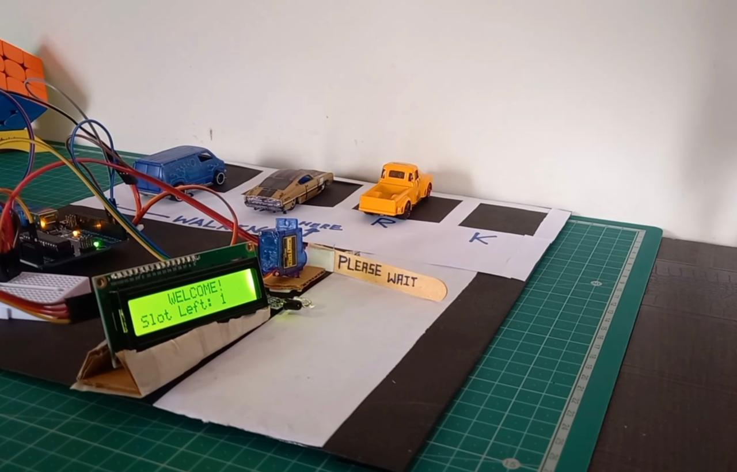

**Fig 9** SMART PARKING SYSTEM

Analysing the results involves assessing the occupancy status and updating the available slots displayed on the LCD. For instance, if the entrance sensor detects a car entering, it increases the count of occupied spaces, and when the car leaves, the exit sensor decrements this count. The difference between the total spaces and occupied spaces represents the available slots. This real-time analysis ensures that drivers accessing the parking facility receive up-to-date information about available spots. It optimizes user experience by minimizing the time spent searching for parking. Moreover, operators can gather data over time, identifying peak hours or popular parking periods. This information aids in making informed decisions regarding space allocation and facility management, such as adjusting pricing or optimizing space utilization strategies. Overall, with just two IR sensors at the entrance and exit points, the system can effectively analyse and update parking slot availability on the LCD displays, offering a user-friendly and efficient parking experience while providing valuable data for operational improvements.

**CHAPTER 3**

**CONCLUSION**

In a smart parking system using only two IR sensors one at the entrance and another at the exit—leveraging IoT technology, the conclusion points towards a significant enhancement in user convenience and efficient space management. The system's simplicity relies on these sensors detecting the presence or absence of vehicles as they enter and exit the parking facility. The data collected by these sensors is then transmitted to a central control system that processes the information to determine the occupancy status of the parking spots.The real-time availability of parking slots is then displayed on LCD screens strategically placed at prominent locations, making it easy for drivers to identify open spots. This straightforward approach drastically reduces the time spent searching for parking, minimizing congestion and optimizing space utilization within the facility.

The conclusion drawn from this implementation highlights the effectiveness of a minimalist yet robust system. Despite using only two sensors, the smart parking system significantly improves user experience by providing accurate and instant information about available parking spots. Drivers can quickly locate vacant spaces without circling the entire facility, resulting in reduced frustration and fuel consumption. Moreover, this simplified setup doesn't compromise on the system's efficiency. The utilization of IoT technology ensures seamless communication between the sensors, control unit, and display screens, guaranteeing reliable and up-to-date information for users. The overall impact of this conclusion underscores the effectiveness of a streamlined approach in smart parking systems. Even with a minimal number of IR sensors at key entry and exit points, the integration of IoT facilitates a smoother parking experience, benefiting both drivers and parking facility operators by optimizing space usage and improving traffic flow. This conclusion affirms that simplicity, when coupled with advanced technology, can create a notably efficient and user-friendly parking solution. The IoT-enabled smart parking system using only two IR sensors is an effective and efficient solution that enhances the user experience and optimizes parking space management.

This system offers several benefits, including reduced congestion, minimized frustration, and improved fuel efficiency for drivers. To further improve this solution, potential future enhancements could include the implementation of smart sensors that detect vehicle size or type. This feature would allow for designated parking for specific vehicles, such as electric cars or handicapped spots. Additionally, a mobile app interface could offer drivers real-time updates on parking availability and enable spot reservation or pre-booking. Integrating payment gateways within the app can facilitate cashless transactions, simplifying the payment process. Another possible enhancement involves integrating the parking system with other infrastructure components, such as security systems, ticketing machines, and access control devices.

This integration would create a comprehensive and efficient parking solution, addressing the broader needs of the parking facility and its users. By leveraging IoT technology and a minimalistic approach, the proposed smart parking system demonstrates its potential to revolutionize the way parking facilities operate. This innovative solution not only optimizes parking efficiency and user experience but also has the potential to reshape the urban environment and foster a more interconnected and sustainable urban landscape.

**3.1** **FUTURE ENHANCEMENT**

Future enhancements in this simplified smart parking system could involve leveraging advanced data analytics and machine learning algorithms to optimize parking operations further. By integrating the existing IR sensors with AI-driven predictive analysis, the system can learn from historical data patterns, such as peak parking times or preferred spots. This enhancement would allow for more accurate predictions of parking availability, enabling proactive management strategies. Additionally, incorporating a mobile app interface could offer drivers real-time updates on parking availability and allow for spot reservation or pre-booking. Integrating payment gateways within the app can facilitate cashless transactions, simplifying the payment process. Moreover, implementing smart sensors that detect vehicle size or type could enable designated parking for specific vehicles, like electric cars or handicapped spots, promoting inclusivity and eco-friendly practices.

As technology advances, potential integrations with smart city initiatives might arise, allowing the parking system to sync with traffic flow data or public transportation schedules, offering users comprehensive mobility solutions. These future enhancements aim to not only optimize parking efficiency and user experience but also pave the way for a more interconnected and sustainable urban environment. Future enhancements in smart parking systems using IoT and RFID tags, along with the development of a dedicated mobile app, promise to bring even greater efficiency and convenience to the parking experience. By integrating RFID technology, each vehicle can be equipped with RFID tags that enable seamless and contactless entry and exit. These RFID tags communicate with IoT sensors installed at entry and exit points, updating the central system in real-time. In addition to this, the mobile app, which connects to the IoT infrastructure, allows users to access real-time parking availability information. Drivers can use the app to view a map of the parking facility, highlighting available parking spots and even reserve a spot in advance. The app can also provide navigation to the chosen parking location. With the combination of IoT, RFID, and a dedicated app, this enhanced smart parking system aims to minimize congestion, reduce the time spent searching for parking, and provide a more convenient and user-friendly parking experience for all.

The proposed enhancement offers a unique solution that leverages IoT technology and a minimalistic approach to provide a highly efficient and user-friendly parking solution. As technology advances, potential integrations with smart city initiatives might arise, allowing the parking system to sync with traffic flow data or public transportation schedules, offering users comprehensive mobility solutions. These future enhancements aim to not only optimize parking efficiency and user experience but also pave the way for a more interconnected and sustainable urban environment.

**REFERENCES**

1. Kumar, Suraj. "Smart Parking System." International Journal for Research in Applied Science and Engineering Technology 11, no. 5 (May 31, 2023): 707–11.
2. Jung, In Hwan, Jae Moon Lee, and Kitae Hwang. "Smart Parking Management System Using AI." Webology 19, no. 1 (January 20, 2022): 4629–38.
3. Shetty, Yashaswi. "Smart Parking System." International Journal for Research in Applied Science and Engineering Technology 6, no. 3: 2286–90.
4. Suruthi, Mano. "Smart Parking System." International Journal for Research in Applied Science and Engineering Technology 6, no. 3: 2966–71.
5. Kumar, Madhumita Manish, and Geetanjali Yatnalkar. "Smart Parking System." International Journal of Advanced Engineering and Nano Technology 4, no. 6 (September 30, 2021): 1–5.
6. Bharathi, V. C. "Smart Parking System." International Journal for Research in Applied Science and Engineering Technology 9, no. VII (July 20, 2021): 1823–26.
7. Mohammad, Alamgir. "Smart Parking System." International Journal for Research in Applied Science and Engineering Technology 6, no. 5 : 81–83.
8. Sandeep, Dr K. S. Keerthiprasad, Manuraj D C, Rakshith Gowda M, and B. L. Manohara. "Smart Parking System." International Journal for Research in Applied Science and Engineering Technology 11, no. 7 (July 31, 2023): 589–99.
9. W Alsafery, B Alturki , S Reiff-Marganiec , K Jambi Smart Car Parking System Solution for the Internet of Things in Smart Cities 2018 1st International Conference on Computer Applications & Information Security (ICCAIS) , p. 1 - 5.
10. M Suresh, P S Kumar, T Sundararajan Iot based airport parking system Innovations in Information, Embedded and Communication Systems (ICIIECS), 2015 International Conference on. IEEE, p. 1 – 5.
11. <https://www.ijeat.org/wp-content/uploads/papers/v9i1/A1963109119.pdf>
12. <https://mobidev.biz/blog/iot-based-smart-parking-system>
13. <https://www.mdpi.com/1424-8220/20/5/1476>
14. <https://link.springer.com/article/10.1007/s11277-022-09705-y>
15. <https://www.researchgate.net/profile/Saidur-Rahman-7/publication/329686583_IoT_Based_Smart_Parking_System/links/5c153f0aa6fdcc494ff7b9be/IoT-Based-Smart-Parking-System.pdf>
16. <https://www.researchgate.net/publication/301610593_Smart_parking_system_for_Internet_of_Things>
17. <https://www.ijrte.org/wp-content/uploads/papers/v7i4s/E1996017519.pdf>
18. <https://www.taylorfrancis.com/chapters/edit/10.1201/9781003193838-67/iot-based-smart-car-parking-system-smart-cities-himanshu-sharma-shruti-talyan-shambhavi-kaushik-kartikeya-dwivedi>
19. <https://ijresonline.com/assets/year/volume-10-issue-2/IJRES-V10I2P102.pdf>
20. <https://ijireeice.com/wp-content/uploads/2022/05/IJIREEICE.2022.10441.pdf>